H.T No
Regulations:
A18

Sreenidhi Institute of Science and Technology
(An Autonomous Institution)
Code No: 7BC03 Date: 05-Feb-2024 (AN)

B.Tech I-Year I- Semester External Examination, Jan/Feb-2024 (Supplementary)
ENGINEERING MECHANICS (ME)

Time: 3 Hours Max.Marks:70

Note: a) No additional answer sheets will be provided.
b) All sub-parts of a question must be answered at one place only, otherwise it will not be valued.
c) Missing data can be assumed suitably.
Bloom's Cognitive Levels of Learning (BCLL)

Remember | L1 | Apply | L3 | Evaluate | L5
Understand | L2 | Analyze | L4 | Create | L6

Part - A Max.Marks:20

Answer all QUESTIONS.

 |  | BCLL | CO(s) | Marks
1 | State parallelogram law. | L4 | CO1 | [2M]
2 | What are the assumptions in developing the theory of perfect frames. | L1 | CO2 | [2M]
3 | Write an expression for centroid of the following areas (i) Triangle (ii) Semicircle | L1 | CO3 | [2M]
4 | State Perpendicular axis theorem. | L1 | CO4 | [2M]
5 | Define the terms (i) Kinematics (ii) Kinetics | L3 | CO5 | [2M]
6 | State and explain work-energy theorem. | L1 | CO6 | [2M]
7 | State Varignon's theorem. | L1 | CO1 | [2M]
8 | State and explain the principle of Virtual work. | L1 | CO2 | [2M]
9 | State D'Alembert's principle. | L3 | CO4 | [2M]
10 | What are the steps followed while drawing free body diagrams? | L2 | CO5 | [2M]

Part – B Max.Marks:50
ANSWER ANY FIVE QUESTIONS. EACH QUESTION CARRIES 10 MARKS.

 |  |  | BCLL | CO(s) | Marks
11. | a) | Find the resultant of the force acting on a particle P shown in Fig.11(a)  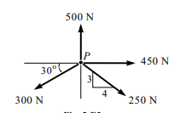  Fig. 11(a) | L3 | CO1 | [5M]
 | b) | Determine completely the resultant of the four forces shown in Fig.11(b). Each force makes an 15^{O} angle with the vertical except the 2000 N force which is vertical.  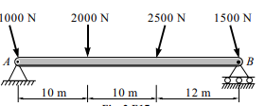  Fig 11(b) | L3 | CO1 | [5M]
12. |  | Determine the forces in all the members of the trusses shown in Fig. 2  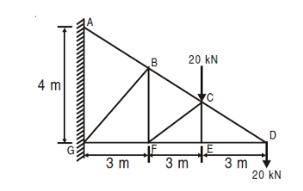  Fig. 2 | L5 | CO2 | [10M]
13. | a) | Two blocks A and B weighing 500N and 1000N respectively, are resting against a wall and the floor as shown fig.. Find the value of the horizontal force P applied to the lower block that will hold the system in equilibrium. Coefficients of friction are 0.25 at the floor and wall and 0.2 between the blocks. | L4 | CO3 | [5M]
 | b) | Find the centroid of the following shaded plane area shown in the Fig.  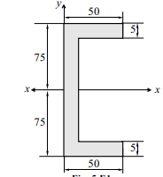 | L3 | CO3 | [5M]
14. |  | The cross-section of a rectangular hollow beam is as shown in Fig.4. Determine the polar moment of inertia of the section about centroidal axes.  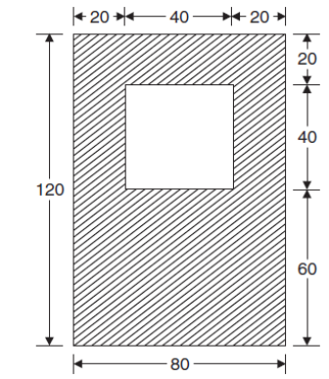  Fig.4. | L4 | CO4 | [10M]
15. | a) | Discuss the rigid body translation. | L3 | CO5 | [5M]
 | b) | Two stones A and B are projected from the same point at inclinations of 45⁰ and 30⁰ respectively to the horizontal. Find the ratio of the velocities of projection of A and B if the maximum height reached by them is the same. | L5 | CO5 | [5M]
16. |  | Determine the acceleration of the system of blocks shown in Fig.5 Assume the pulleys to be massless and frictionless.  Take m1 = 8kg, m2= 2 kg and m3= 3 kg. Also, determine the tension in the strings connecting the blocks.  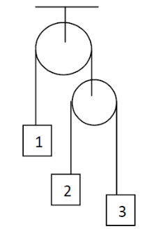  Fig.5 | L5 | CO6 | [10M]
17. |  | Explain about:
 | a) | Method of joints. | L2 | CO1 | [5M]
 | b) | The working principle of screw jack. | L2 | CO2 | [5M]
18. | a) | State and prove  (i) Perpendicular axis theorem  (ii) Parallel axis theorem of moment of inertia | L1 | CO4 | [4M]
 | b) | Express the acceleration of a particle in tangential and normal components. | L3 | CO5 | [3M]
 | c) | State the advantage of energy and momentum methods in the analysis of plane motion of rigid bodies | L2 | CO6 | [3M]
-- 00 -- 00 –

